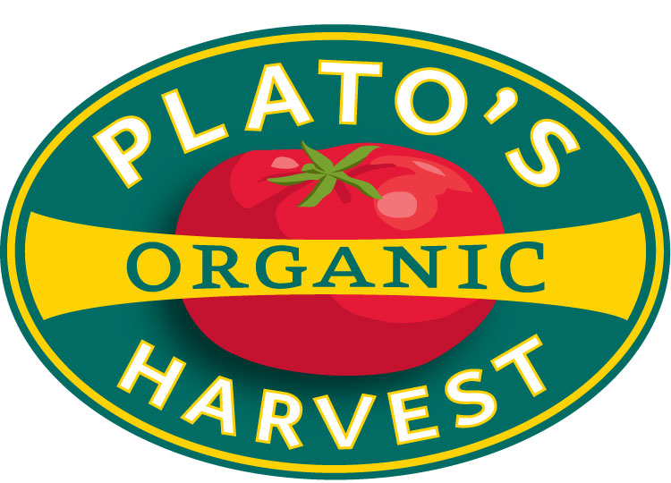

Plato’s Harvest Organic Farm

2025 CSA Application

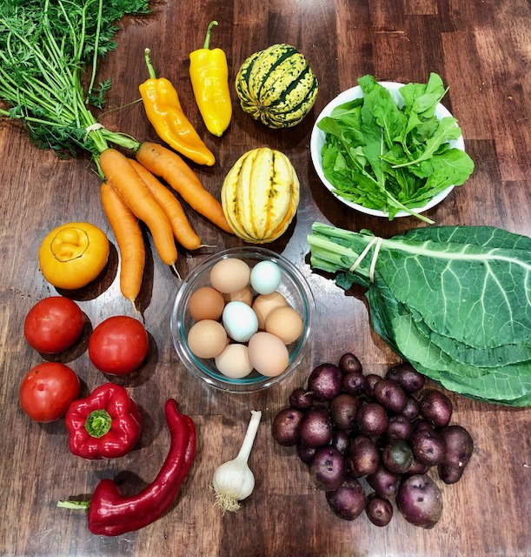
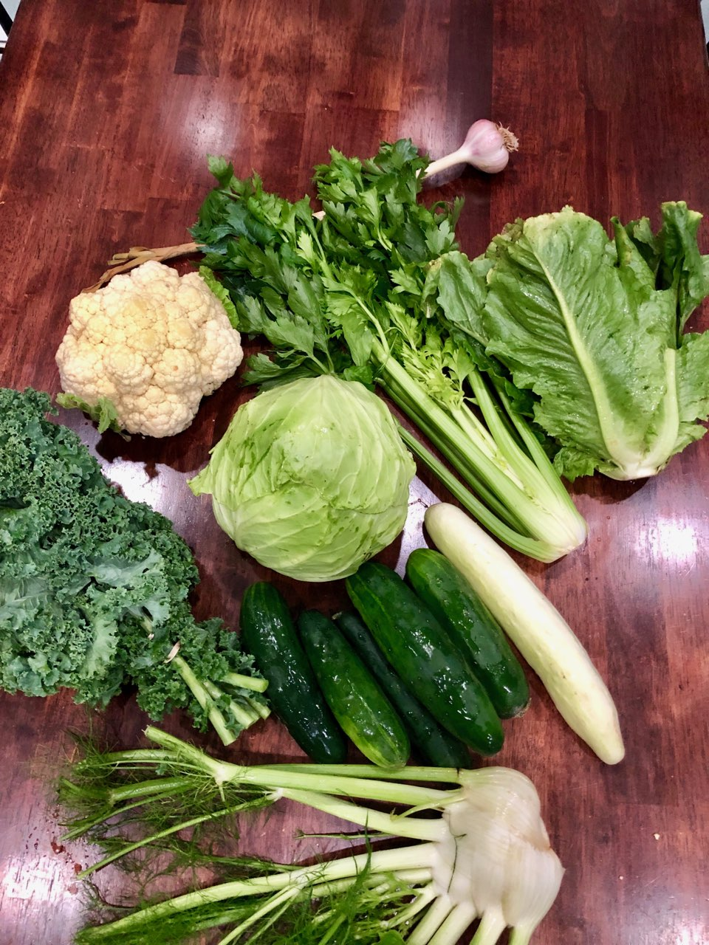

Plato’s Harvest is a certified organic mixed vegetable farm. 2025 is our twentieth year offering CSA shares. Shares are distributed for a 10 week period, details below. The share price is $40 / week . Distribution will begin in late May / early June, exact date to be determined by growing conditions.

What will I get in each share?

Your share each week will vary in size and variety throughout the season. You can get a good sense of what the shares look like from past years by visiting us on the facebook.

Sample Produce from Plato's Harvest (this is a partial list):

Greens (arugula, lettuce, salad mix, kale, collards, choi, spinach, etc), beets, broccoli, cabbage, cauliflower, carrots, corn, cucumbers, eggplant, fennel, garlic, kohlrabi, celery, leeks, onions, melons, peppers, radish, turnip, summer and winter squash, tomatoes.

Why would I do this?

The CSA model began as a way for farmers to raise startup capital early in the season, when there is nothing coming in and lots going out. Our share is designed to reasonably provide a family of four, that eats mainly at home, with the freshest, seasonally-available, organic produce for the week – obviously some will need to supplement, and for some it will be a bit too much. If you are eating out 3 or 4 nights a week – this is not for you! We are targeting folks that appreciate an abundance of fresh, local, organic produce, have a love for cooking, an interest in nutrition, and a general passion for food!

2025 finds us (again) trying a new model – a 10 week 'prime' CSA which gets you greens and fruits and all the best that early summer in New England offers. This share will end late July / early August, so things like tomatoes and corn will be just beginning and fall favorites like winter squash, carrots, onions, leeks will not have begun yet. If this early season goes well and there is wild enthusiasm to continue, we will offer a fall share, details TBD.

Details:

Distribution will take place on Tuesday afternoons between 5 pm and 6 pm at Farm Headquarters, 131 Chestnut St., Middleboro, MA. With a little prior notice we can accommodate a later, or next-morning pickup.

Distributions begin in late May as greens and other early-season crops become available. You will arrive to find the week's offerings harvested, washed and laid out for you to choose from to assemble your share according to what is posted on the board.

If you are away, ask a friend to pick up your share. If you would prefer we not
harvest your share for that week, just let us know. There are no refunds for missed shares. Please understand that your share is custom harvested, washed and prepared each distribution day – if you find yourself unable to pick up on a Tuesday I can usually hold overnight – if given notice.

We also encourage you to visit the Plymouth Farmers' Market for the rest of your weekly grocery needs – details here: plymouthfarmersmarket.org.

Thanks for your support, and don't take food from strangers!

Plato's Harvest 2025 CSA Application

Make check payable to Plato's Harvest Organic Farm and send along with this (printed) insert to:

Plato's Harvest
131 Chestnut Street
Middleboro, MA 02346

CSA Produce Share - $400

Name: _____________________________________

Address:___________________________________

Email:_____________________________________

Phone: _____________________________________
(please include a phone number where you can be reached on share day!)

Questions or comments, please contact:

David Purpura
(508) 315-9429
platosharvest@yahoo.com

